**Caroling & Bowling/Dinner**

**Sunday, December 1, 2019**

**MC900140953[1]MC900292482[1]**

**10:00 a.m. arrival – Caroling at: 10:30**

**The Fairway Knoll Senior Community (262) 735-7900**

**N112W17500 Mequon Rd.**

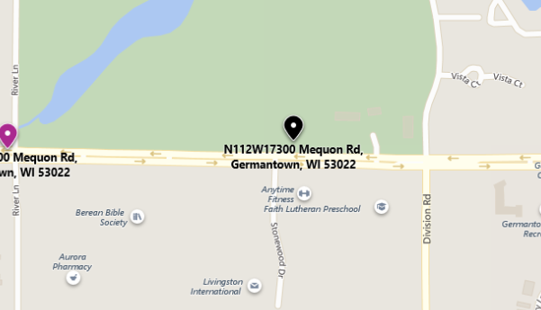

**Germantown, WI  53022**

**(From Richfield: Head East on Freistadt Rd., turn right on River Ln., turn left on Mequon Rd., & about 0.3 mi. Fairway Knoll will be on your left.)**

**Scouts need to be in uniform – photos will be taken.**

**12:00pm–3:30pm – Bowling & Dinner/Awards at**

**Village Bowl**

Assignment:

Opening – Webelo II

Prayer – Tigers

Closing – Bears

Clean up - All

**N86 W18330 Main St.**

**Menomonee Falls, WI 53051**

**(South on Division, West on County Lind Rd.,**

**South on Maple Rd, East on Main St.)**

**FREE bowling & lunch for scouts!**

**$10.00 / sibling for bowling and lunch**

**$4.00 / non-scout for lunch only**

**(If you have not yet done so, sign up with Robin Larson)**

**In the spirit of the Christmas season, please bring a new unwrapped toy to donate to Family Promise of Washington County**

Questions?: Robin Larson

Parent Committee Member

Call/Text: (262) 424-4022

Email: [Jrchlarson4@gmail.com](mailto:Jrchlarson4@gmail.com)

Christy Zach

Pack Treasurer

Call: (262) 227-5754

Email: [christy3646@gmail.com](mailto:christy3646@gmail.com)

www.RichfieldScouts.com